Network:
A computer network is a digital telecommunications network for sharing resources between nodes, which are computing devices that use a common telecommunications technology.

Types of Computer Network
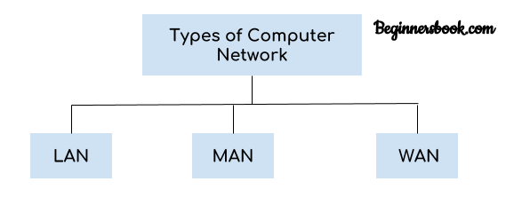

There are mainly three types of computer networks based on their size:
1. Local Area Network (LAN)
2. Metropolitan Area Network (MAN)
3. Wide area network (WAN)

1. Local Area Network (LAN)
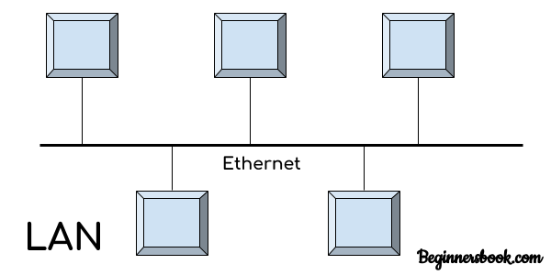
1. Local area network is a group of computers connected with each other in a small places such as school, hospital, apartment etc.
2. LAN is secure because there is no outside connection with the local area network thus the data which is shared is safe on the local area network and can’t be accessed outside.
3. LAN due to their small size are considerably faster, their speed can range anywhere from 100 to 100Mbps.
4. LANs are not limited to wire connection, there is a new evolution to the LANs that allows local area network to work on a wireless connection.

2. Metropolitan Area Network (MAN)
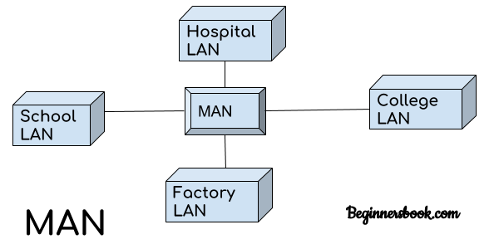
MAN network covers larger area by connections LANs to a larger network of computers. In Metropolitan area network various Local area networks are connected with each other through telephone lines. The size of the Metropolitan area network is larger than LANs and smaller than WANs(wide area networks), a MANs covers the larger area of a city or town.

3. Wide area network (WAN)
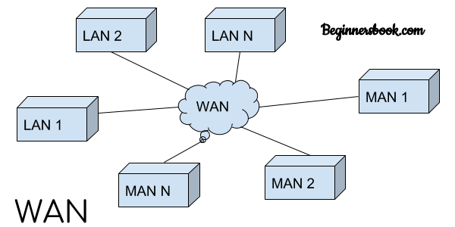
Wide area network provides long distance transmission of data. The size of the WAN is larger than LAN and MAN. A WAN can cover country, continent or even a whole world. Internet connection is an example of WAN. Other examples of WAN are mobile broadband connections such as 3G, 4G etc.

A web application is a software application that runs on a remote server. In most cases, Web browsers are used to access Web applications, over a network, such as the Internet. Some web applications are used in intranets, in companies and schools, for example.
Web applications include online forms, shopping carts, word processors, spreadsheets, video and photo editing, file conversion, file scanning, and email programs such as Gmail, Yahoo and AOL. Popular applications include Google Apps.

